Title
  - Subtitle

Full Name Author #1 || Author #1 email address || Author #1 Affiliations
Full Name Author #2 || Author #2 email address || Author #2 Affiliations

ACM Category 1 || ACM Category 2 || ACM Category 3

Keyword 1 || Keyword 2 || Keyword 3

Abstract
The abstract should state briefly the purpose of the research, the principal results and major conclusions. Abstracts should not exceed 250 words. Abstracts are often presented and read as stand-alone text. Avoid the use of references and abbreviations.

Introduction
This document is a template to submit a manuscript to Journal of Simulation Engineering (JSimE) (Consortium for True Open Access in Modeling and Simulation, 2017). The use of this template will enable the conversion of your article into the (X)HTML document to publish in JSimE.
Authors should use the standard features of Microsoft Word and the ones available in this document template. Avoid creating new Font Styles or use Add-ins because they are not supported.
The Title of the manuscript should be formatted using the Title Font Style. Subtitle is supported and should be formatted using the Subtitle Font Style and placed below the Title.
Each author information should be placed in separate lines and formatted using the AuthorInfo Font Style. The author information line should contain the author’s full name, email address, and affiliation. These fields should be separated using || (two pipe symbols). If an author is affiliated to more than one institution, each institution should be provided separated by ||.
ACM Categories should be provided after the authors information and formatted using the Categories Font Style. The categories should be separated by ||. Please refer to The 2012 ACM Computing Classification System to select the proper terms to classify your work.
Keywords should be provided after the ACM categories and formatted using the Keywords Font Style. Keywords should be separated by ||. Please provide between 3 to 5 keywords.
The Abstract heading should be formatted using the Heading 1 Font Style and the abstract text should be formatted using the Normal Font Style.
The manuscript text should be formatted using the Normal Font Style.
Sections, subsections, etc should be formatted using the proper Headings Font Styles (i.e., Heading 1, Heading 2, Heading 3, and Heading 4).

Equation
Equations should be inserted in the document using the standard Microsoft Word Equation feature located at Insert – Equation in the menu (see Figure 1).
Figure 1 Insert – Equation menu option.
Example of Equation.
$$A=\int_{0}^{1}{xdx}, B=\sum_{i=1}^{j}{a_{i}}, C=πr^{2}$$

Illustrations
Figures should be embedded in the document and, if necessary, a caption should be provided. You should use the menu options Insert – Pictures (see Figure 2).
Figure 2 Insert – Pictures menu option.
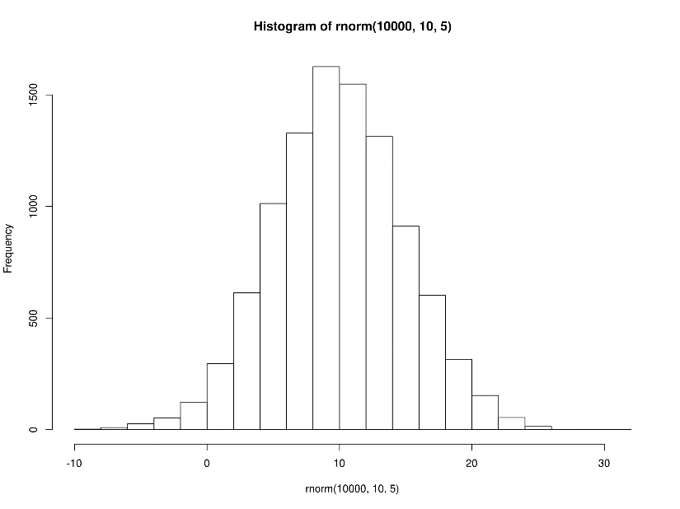
Figure 3 Example of a Figure.
NOTE 1: “Copy and paste” figures from other tools is not supported.
NOTE 2: Cross-references in the Figure’s caption is not supported.

Tables
Tables should be embedded in the document and, if necessary, a caption should be provided. You should use the menu options Insert – Table (see Figure 4).
Figure 4 Insert – Table menu option.
Name | Items
R1 | C1 | C5 | C9
R2 | C2 | C6 | C10
R3 | C3 | C7 | C11
R4 | C4 | C8 | C12
Table 1 Example of a Table.
NOTE 1: Cross-references in the Table’s caption is not supported.
NOTE 2: Table captions should be placed below the table.

Code
Code snippets must be formatted using the HTML Preformatted style. Follows a code snippet example:
PUSH c TO sd.waitingCustomers
IF sd.waitingCustomers.length = 1
THEN SCHEDULE CustomerDeparture( sd) @ (t + sd.serviceDuration())

Inline code should be formatted using the Courier New font.

Footnotes
Footnotes should be inserted using the standard Microsoft Word References – Insert Footnote feature (see Figure 5).
Figure 5 References – Insert Footnotes menu option.

Cross-References
Cross-references should be used to reference other parts or components of the manuscript (see Figure 6). The option “Insert as hyperlink” must be checked to the converter recognize the text as a cross-reference (see Figure 7).
Figure 6 References – Cross-reference menu option.
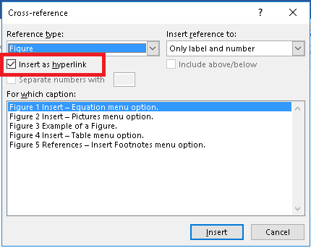
Figure 7 Check box Insert as hyperlink.

Citation and Bibliography
Bibliography should use the Microsoft Word built-in features located at the References menu. References should use the American Psychological Association (APA) style. A tutorial about this style can be found at the APA website.
All bibliographic entries should be first registered in the Microsoft Word using the Managed Source feature (see Figure 8).
Figure 8 Manages all bibliography entries
The citations in the manuscript should use the References – Insert Citation menu option (see Figure 9).
Figure 9 References – Insert Citation menu option.
The manuscript author is responsible to identify and solve any citation ambiguity. If the same list of authors, and in the same order, publish more than one article in the same year, then a lowercase letter should be inserted after the year. For instance, the following two ambiguous entries
Author1, F.N., & Author2, F. N. (2010) Article 1
Author1, F.N., & Author2, F. N. (2010) Article 2
should be changed to
Author1, F.N., & Author2, F. N. (2010a) Article 1
Author1, F.N., & Author2, F. N. (2010b) Article 2
The bibliography section should be inserted using the References – Bibliography menu option (see Figure 10).
Figure 10 References – Bibliography menu option.

Acknowledgements
Acknowledgments should be placed in a separate section at the end of the article before the bibliography, named Acknowledgements or Acknowledgement and formatted using the Heading 1 Font Style. Acknowledgments must not be included on the title page. The acknowledgement text should be formatted using the Normal Font Style. The names of funding institutions and organizations should be written in full.

Bibliography
Consortium for True Open Access in Modeling and Simulation. (2017). Journal of Simulation Engineering. Retrieved from https://www.jsime.org

The Insert Footnote is located at the References menu option in MS Word 2016.

